

ProQuest eLibrary Tutorial

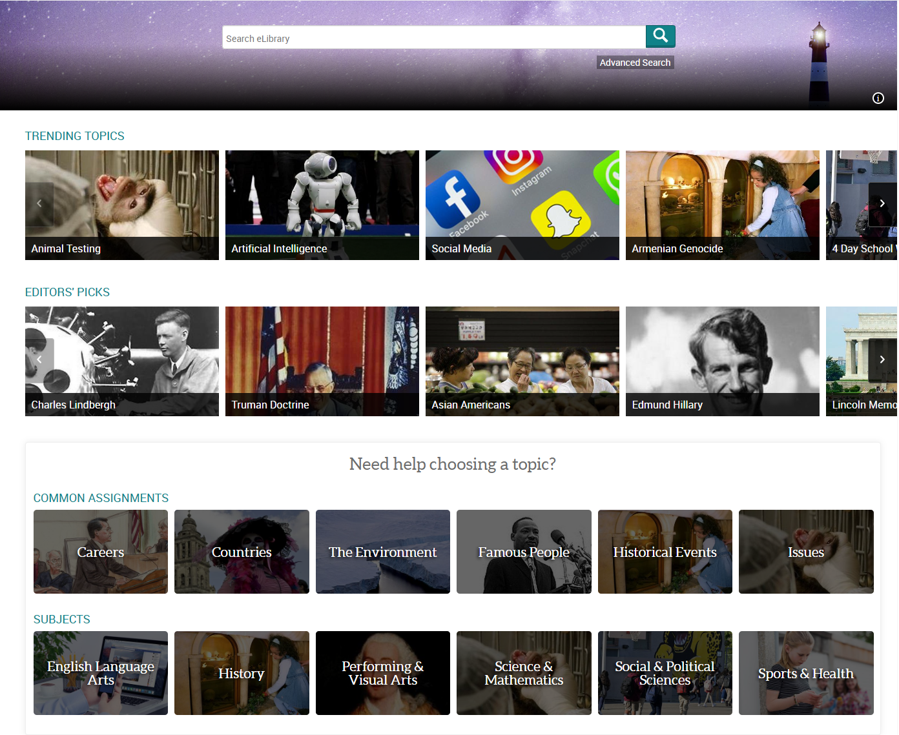

Part One: Access to ProQuest eLibrary

- Go to GraceU website https://graceu.edu/ and mouse over Library & Resources.
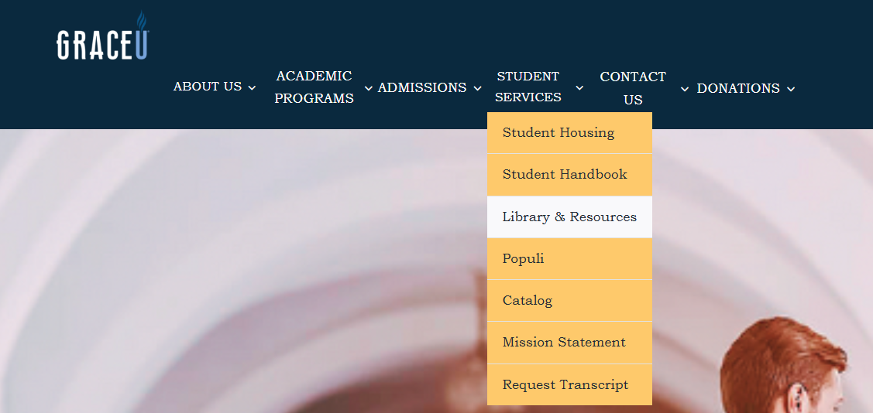
- Click on ProQuest.
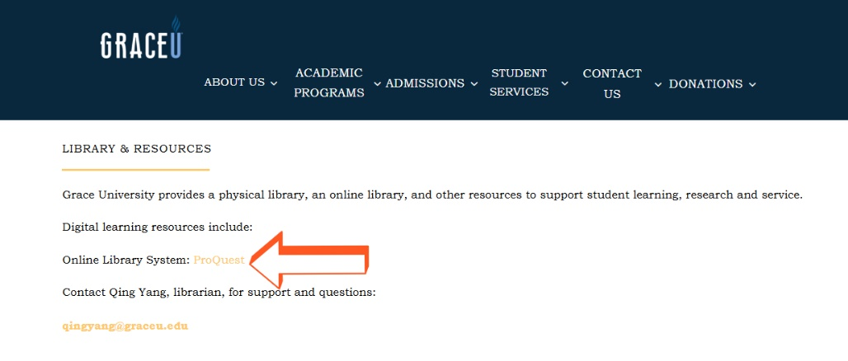
- Use GraceU credentials to access ProQuest eLibrary.
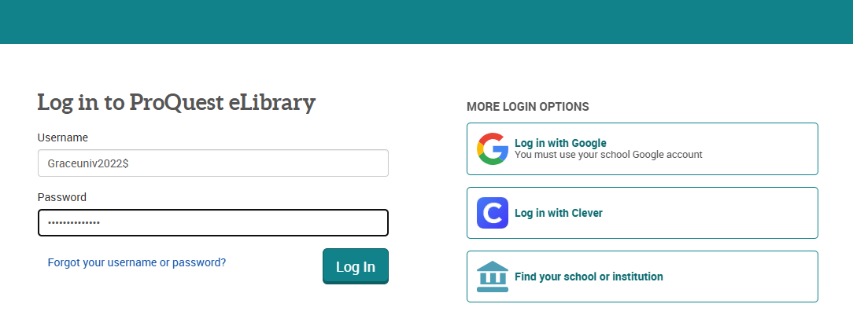

Part Two: ProQuest eLibrary Overview

There are five sections on ProQuest eLibrary homepage.
- Search Box: basic or advanced search by key words.

- Trending Topics: research topic pages that are most viewed by users.

- Editors’ Picks: research topics that might be overlooked or trending news.

- Common Assignments: easy access to research topics for your essay.

- Subjects: categorized research topics in six subjects.

Research Topics on the upper left corner provide us with another access point to Common Assignments and Subjects.
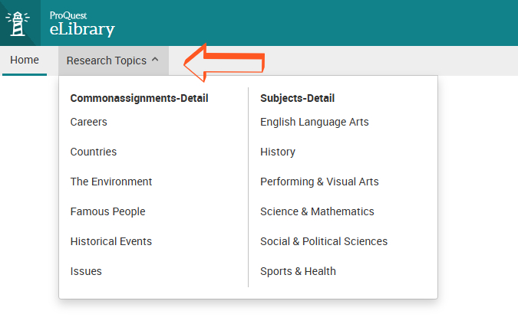

Part Three: Search ProQuest eLibrary

We can start from each of the five sections on the homepage.
- Search Box
Type in key word(s) in the search box.

Since Climate Change is a very broad topic, we have a long list of results including the topic Climate Change followed by images and articles.
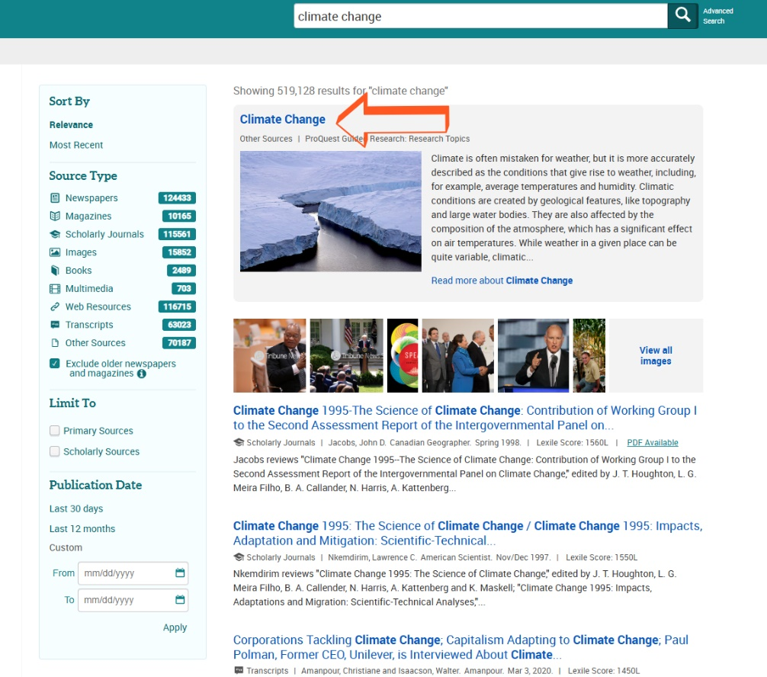

We can narrow down our search results by source type, limit to primary and/or scholarly sources, and publication date.
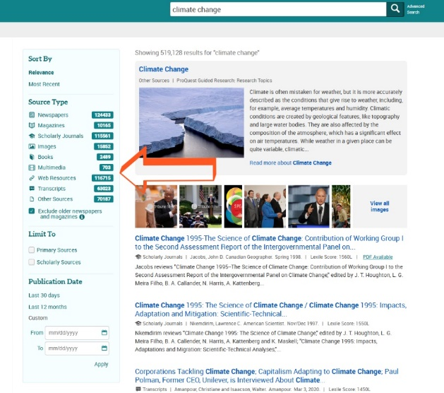
*Boolean search using AND, OR, NOT could be used to find research results with more precision.
Advanced search allows us to use the same criteria as in basic search plus Lexile Score (University Readiness Range generally spans 1300L to 1450L) to narrow down the search results.
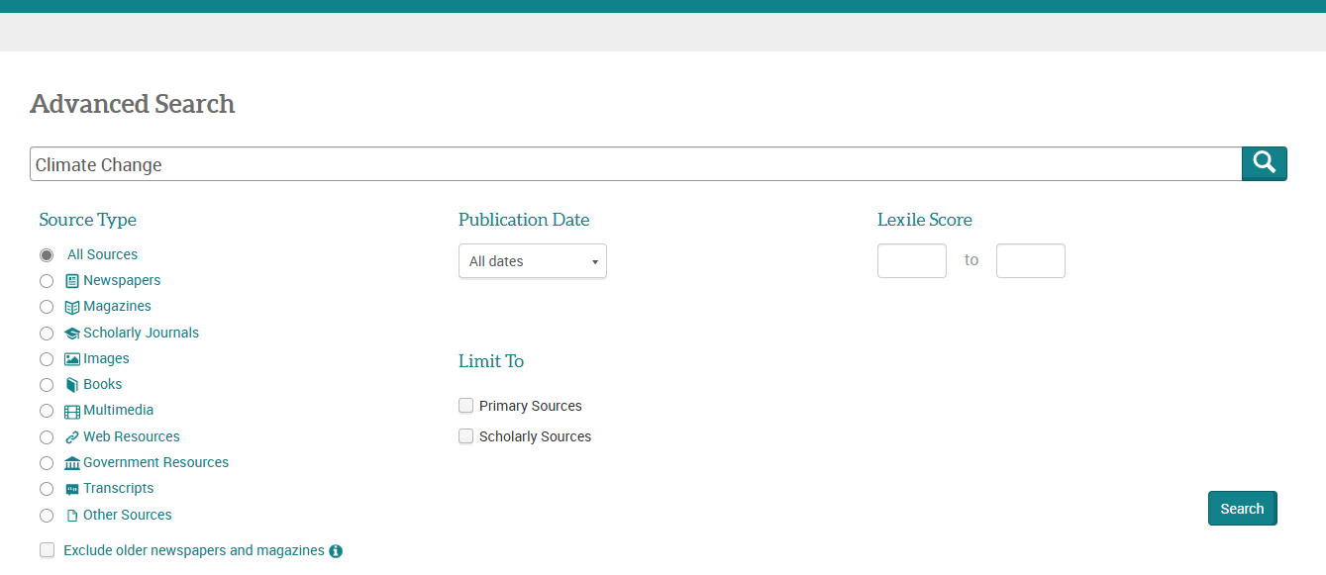
- Trending Topics
We can choose a topic on the carousel. Research Topic Page content sections will vary with each topic. This is an example of the topic page Artificial Intelligence.
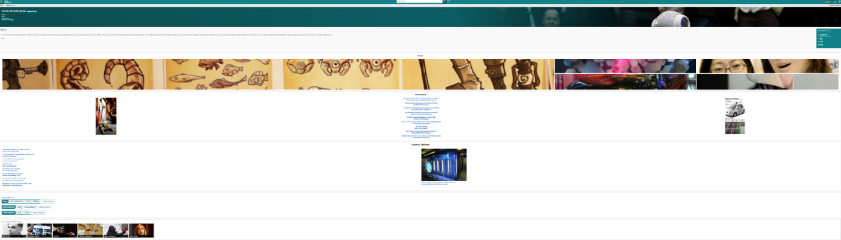
On the upper left corner of the topic page, we have the contents of the topic. The links take us to each available section.
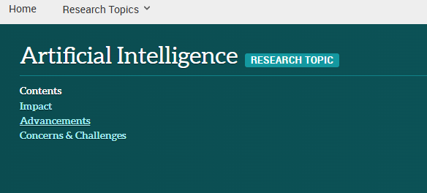
Underneath Contents is a brief overview of the topic, which is an excerpt from a document within eLibrary. Clicking on more would take you to the full text article.
Underneath the overview, articles, images and other types of search results are listed. Clicking a result would bring up the full text article.
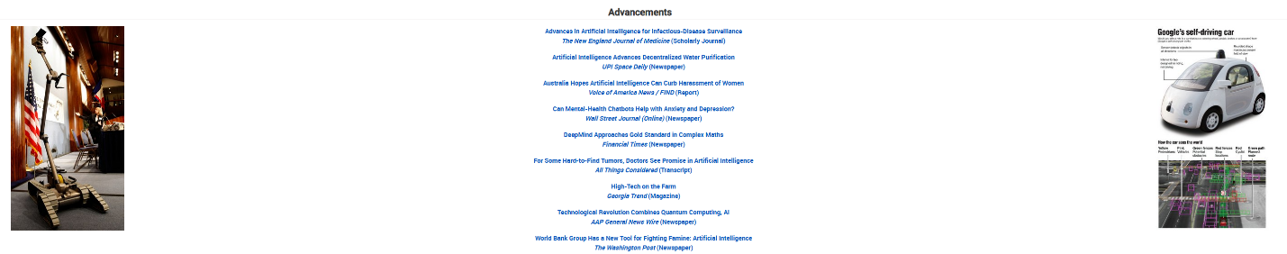

On the bottom of the page, you may see where this Research Topic is indexed in both Subjects and Common Assignments, and you may click and browse within those hierarchies. Related research topics are also available.
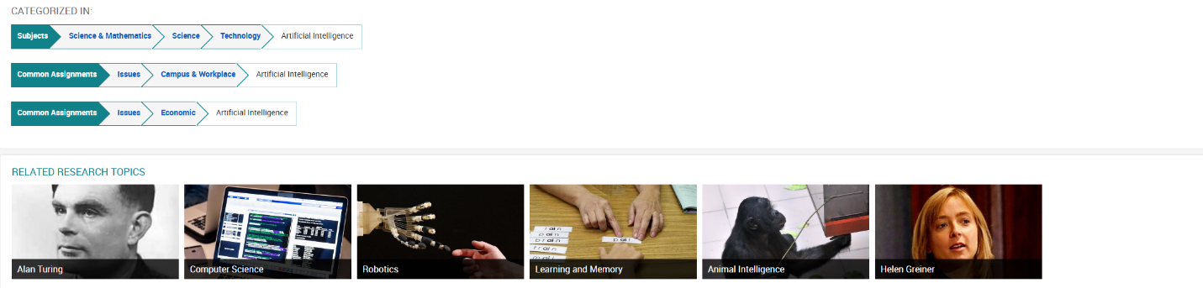
- Editors’ Picks
We can choose a topic on the carousel to go to the topic page.
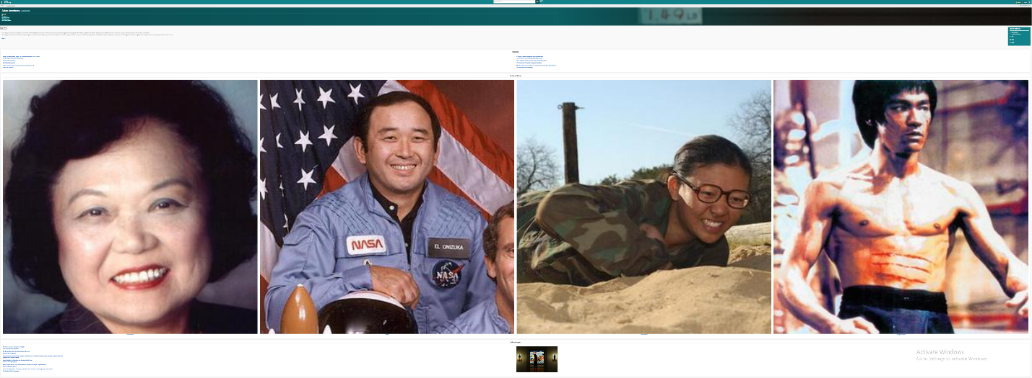
- Common Assignments
There are six common assignments topics. When we click on a topic, we will find the subtopic tabs. For example, the path Common Assignments> The Environment>Climate would take you to the same topic page from the basic search “Climate Change”.
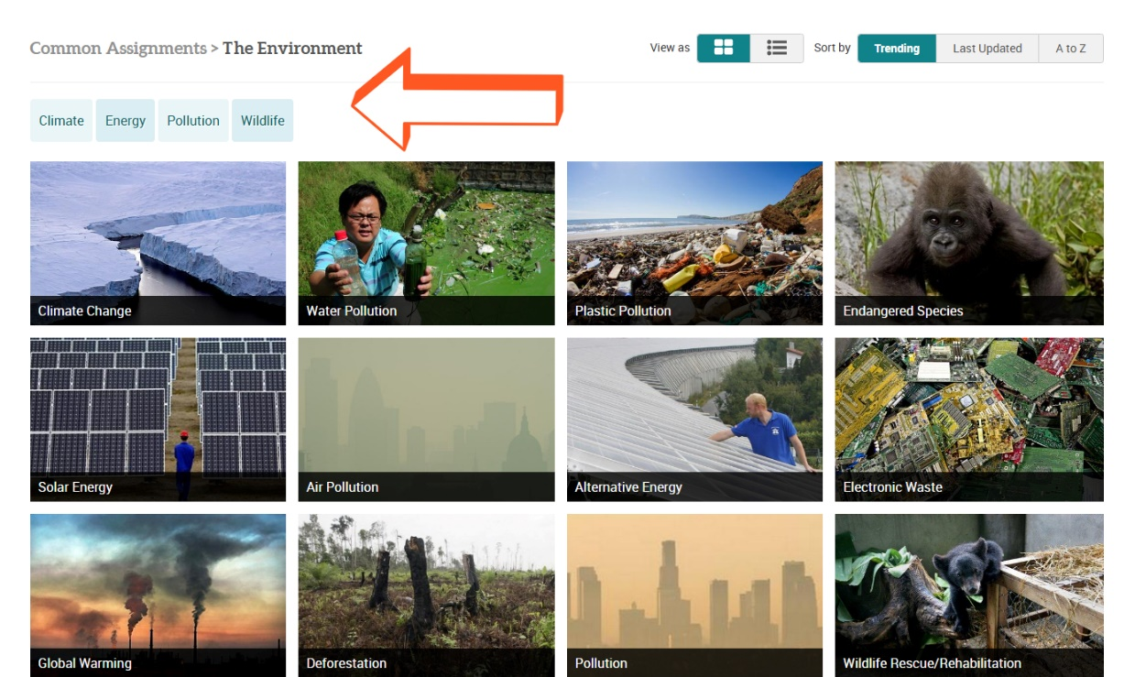
- Subjects
Research topics are categorized into six subjects. When we click on a subject, we will find the subtopic tabs. For example, the path Subjects > Science & Mathematics>science would take you to the same topic page from the basic search “Climate Change”.
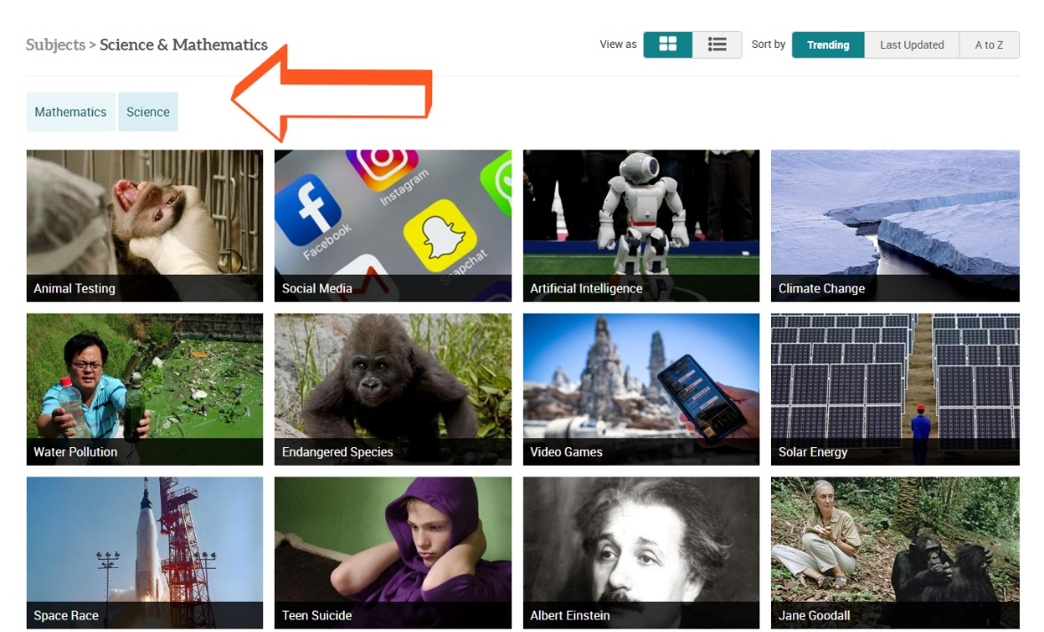

Part Four: Full Text Article

Clicking on the title will take you to the full text article. We have the option to translate the article from English to other languages including simplified and traditional Chinese. We can read the article either in text or original PDF version. We can also listen to the article.

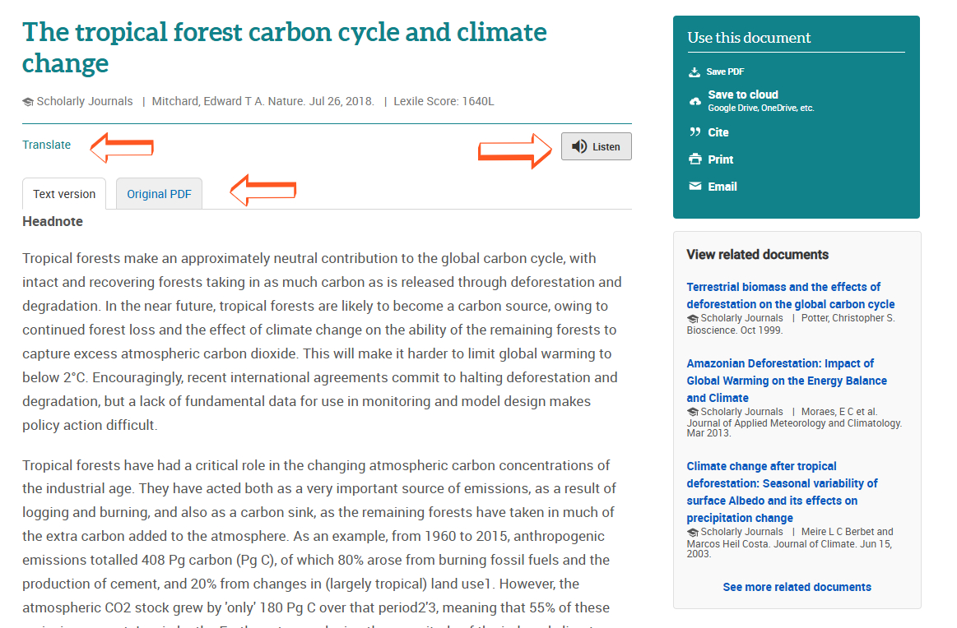
There is a box where we can save PDF, save to cloud, cite (GU’s writing and formatting style is MLA), print and email the article. Underneath the boxes we also have the related documents list.
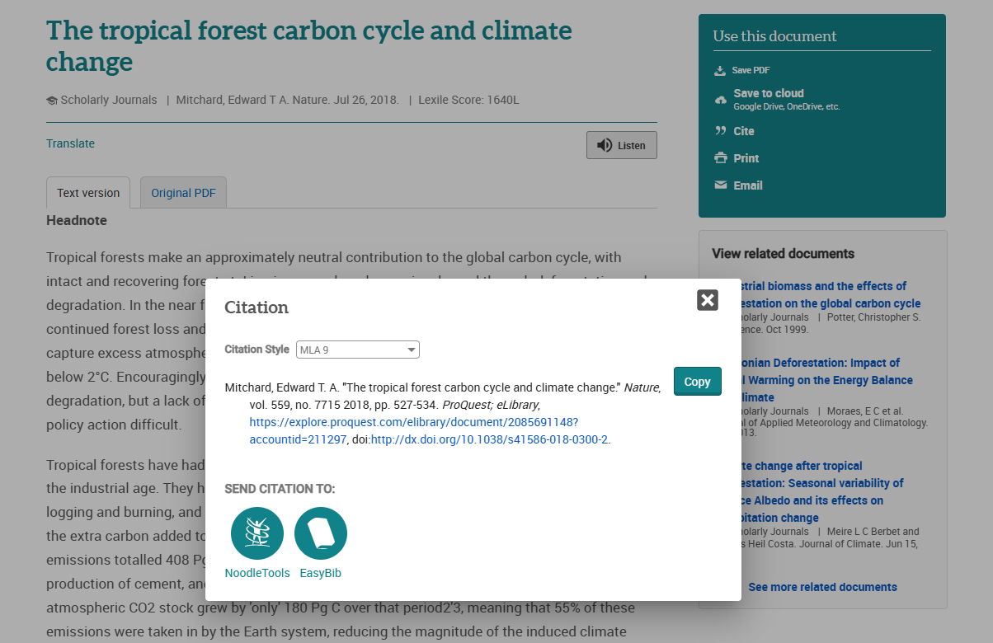

Thank You!
Questions?
qingyang@graceu.edu



